**DIP CA1 Reoprt 趙新元 B10505057**

**1.**

(a)

The effective resolution is reduced, but since it's increased back, it might visually appear similar to the original, though some blurring might occur due to interpolation.

(b)

Similar to (a), but with more aggressive resizing. The effective resolution is reduced, and more blurring may occur.

(c)

Even more aggressive resizing. The effective resolution is significantly reduced, leading to more noticeable blurring.

(d)

The most aggressive resizing among the options. The effective resolution is substantially reduced, resulting in a more blurred image.

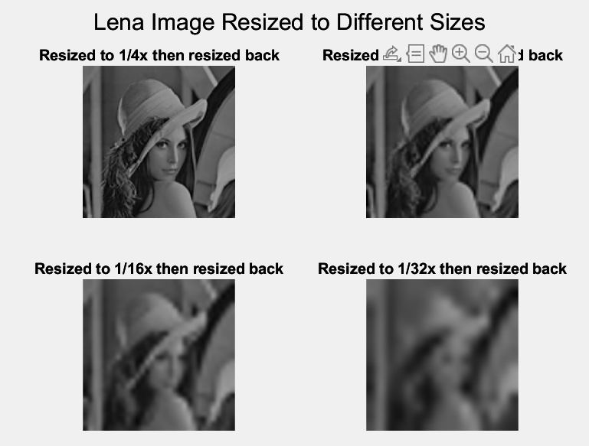

As we can see the figure above, **we don’t obtain the same result**. Due to the interpolation method used by *imresize()*, there could be some loss of detail, and the images may not be precisely identical. By observation, we can find that the image gets more blurred when the resize rate gets larger.

Here is the same image using different interpolation method to resize the image to 1/8 of the original dimension.

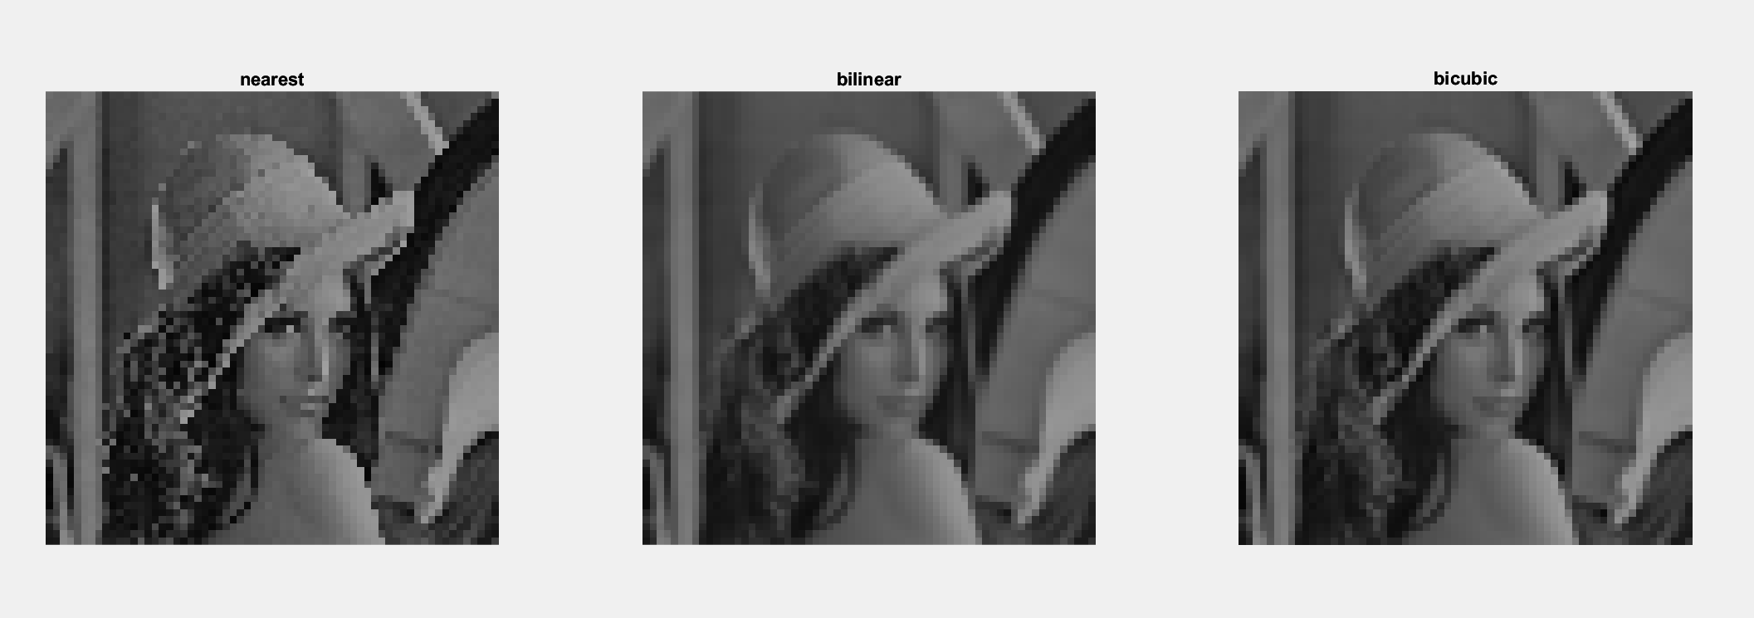

**2.**

8 bit planes of the cameraman image

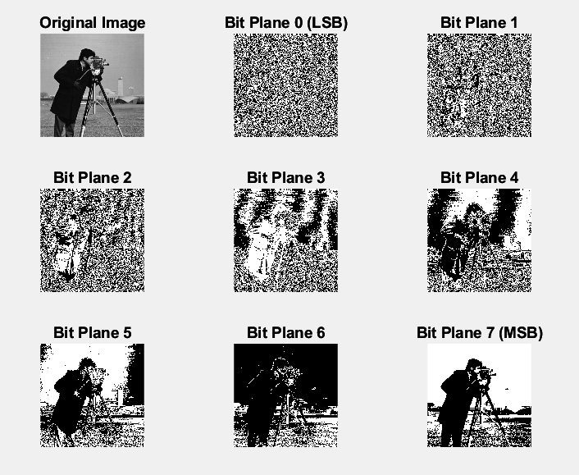

When executing the command “*all(c7(:) == ct(:));”* the command window shows: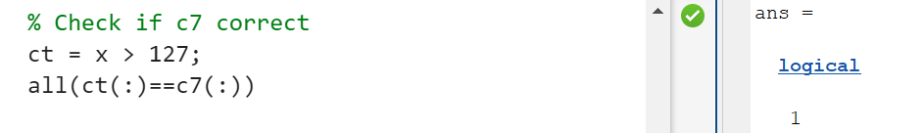

We get 1, which means “True” in computer, hence we know c7 and ct are identical.

Now we reconstruct the image by following instructions.

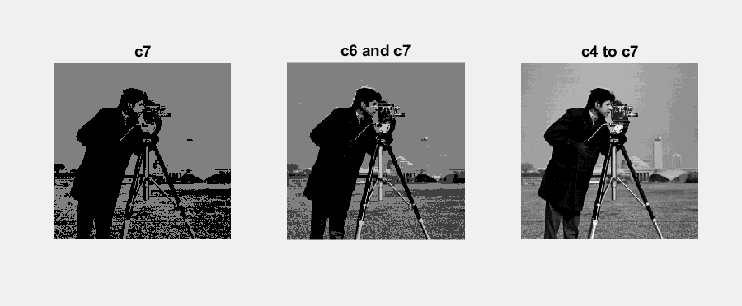

By observation, we can tell bit planes closer to the most significant bit (c7 in this case) contain more detailed information and contribute more to the overall structure of the image. Adding more lower bit planes to c7 enhances the image’s visual appeal. It’s because the lower bit planes represent less significant information, such as fine textures and subtle variations in intensity.

**3.**

Histogram equalization

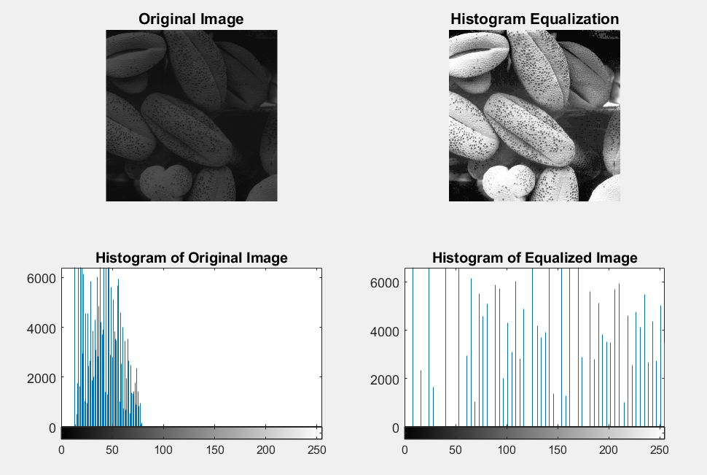 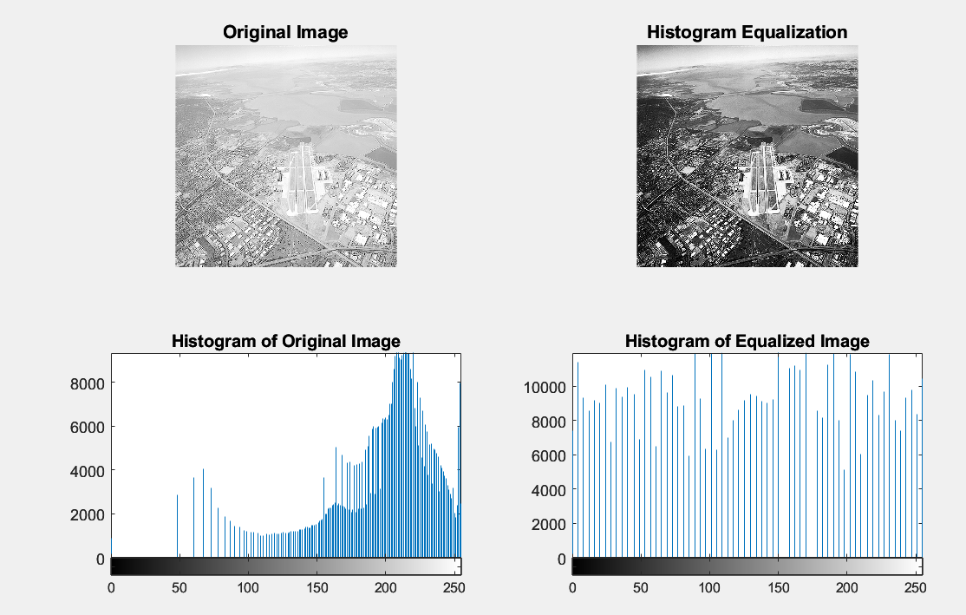

Perform histogram stretching using the *imadjust* function

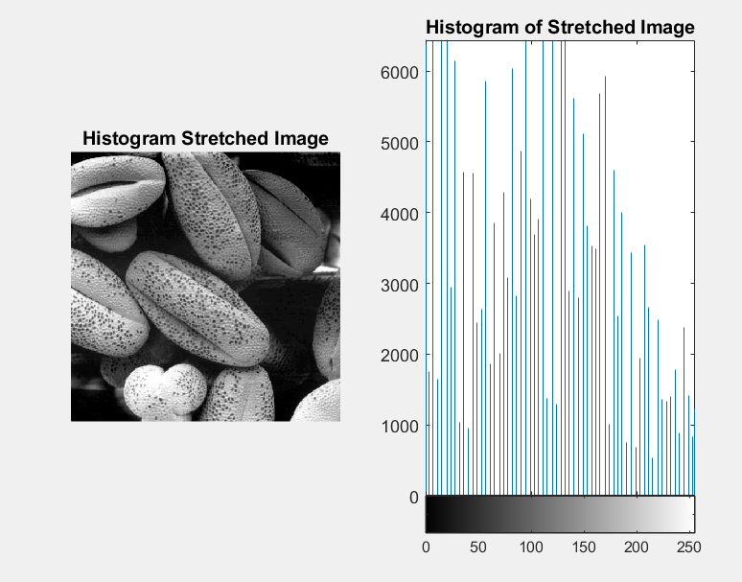

For *pollen.tif*, I use *low_in = 0.06*; *high_in = 0.3*; *low_out=0*; *high_out=1*, because the intensity mostly ranges from 25~75 in the original histogram. This adjustment darkens the shadows without removing too many details, making the object clearer at the same time.

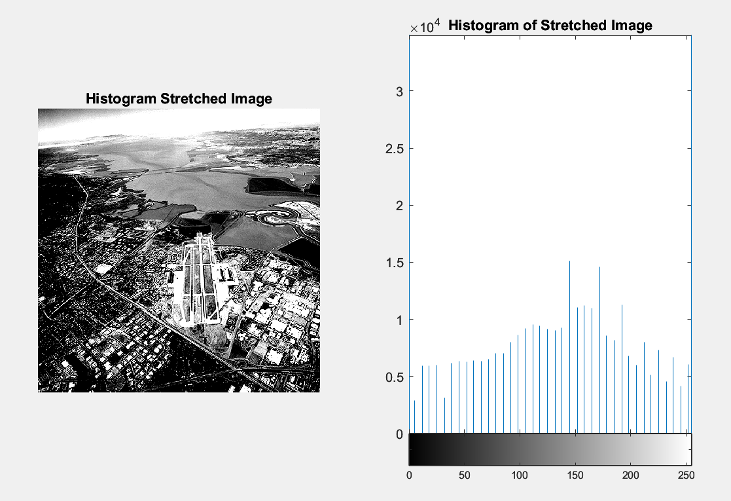

For *aerial.tif*, I use *low_in = 0.75*; *high_in = 0.9*; *low_out=0*; *high_out=1*, because the intensity mostly ranges from 150~250 in the original histogram. This adjustment removes the high-frequency noise in the original image while preserving the city lights at the same time.

**4.**

Transformed images, fs, fsr, and fss.

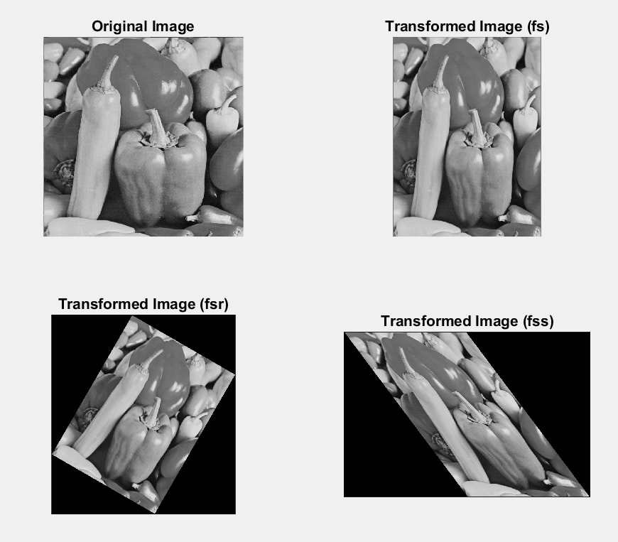

4 pairs registered image of *fs*, *fsr* , and *fss*.

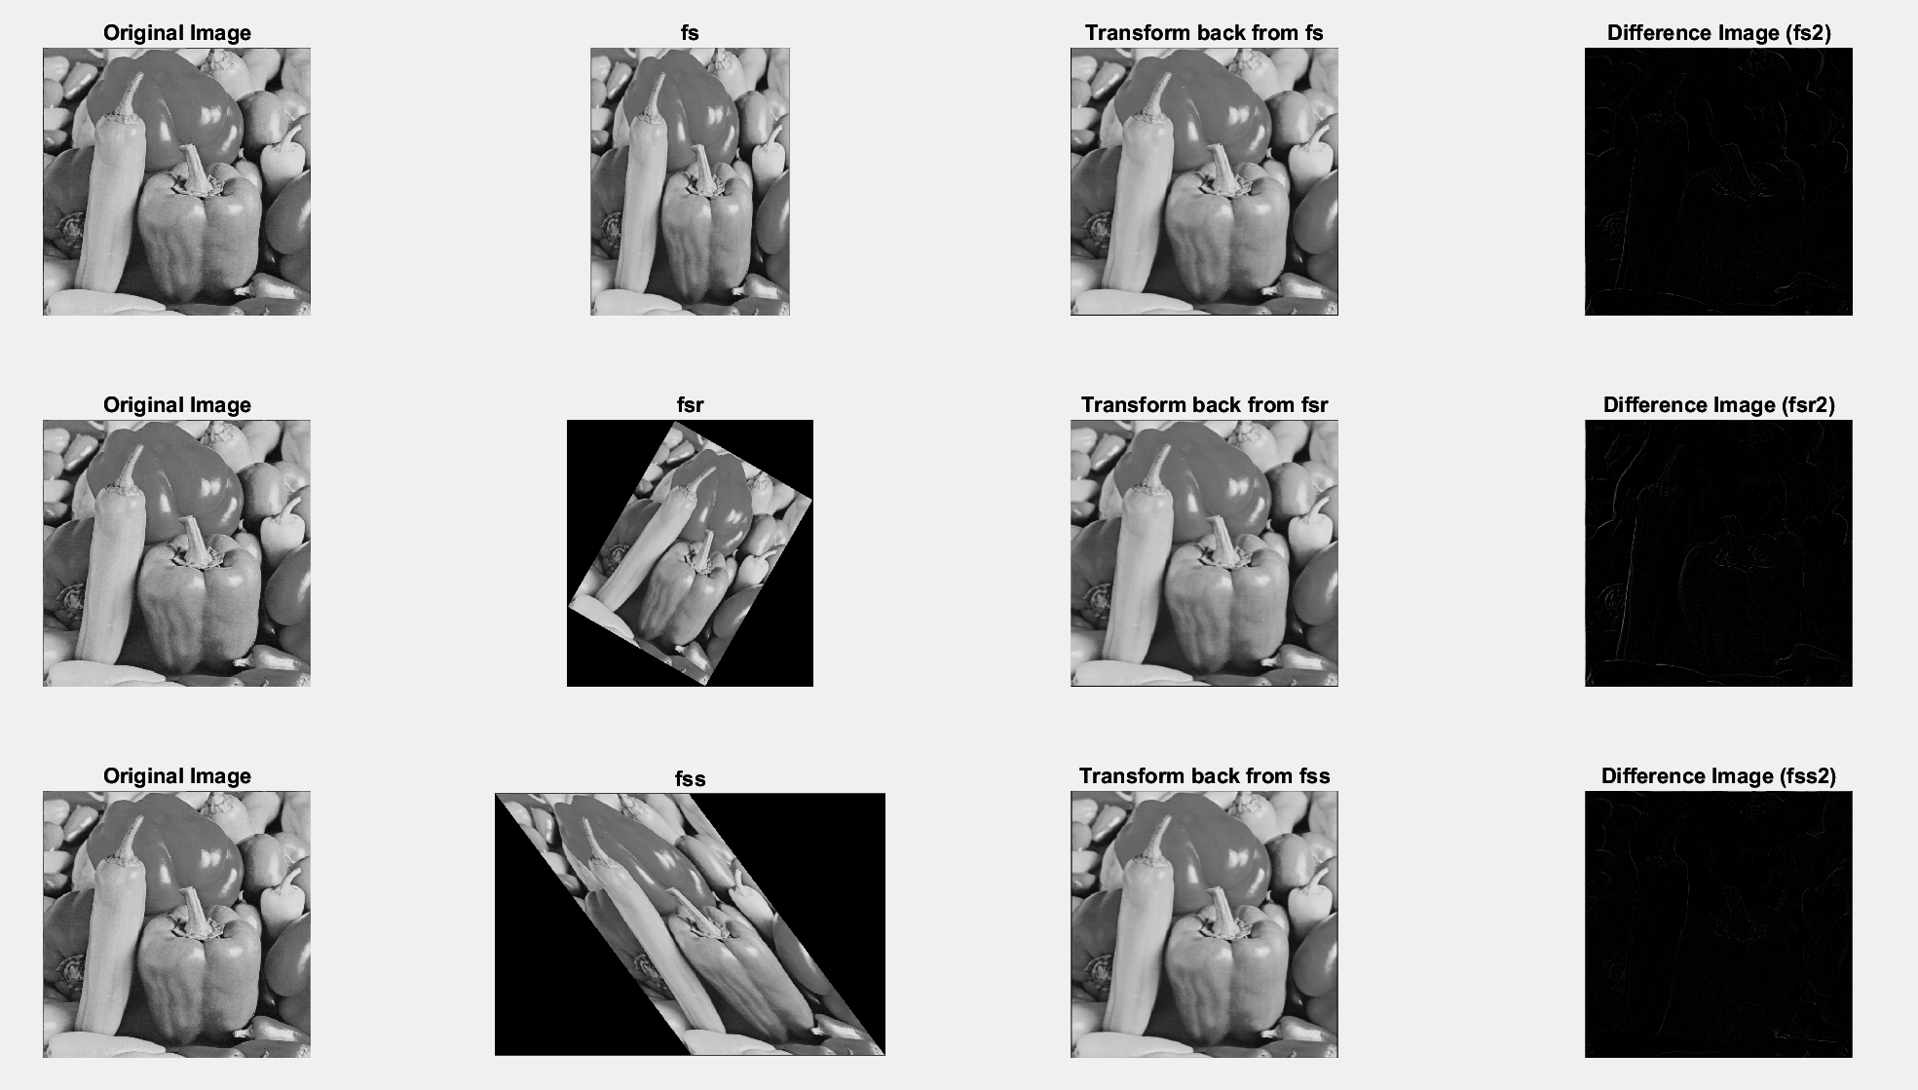

8 pairs registered image of *fs*, *fsr* , and *fss*.

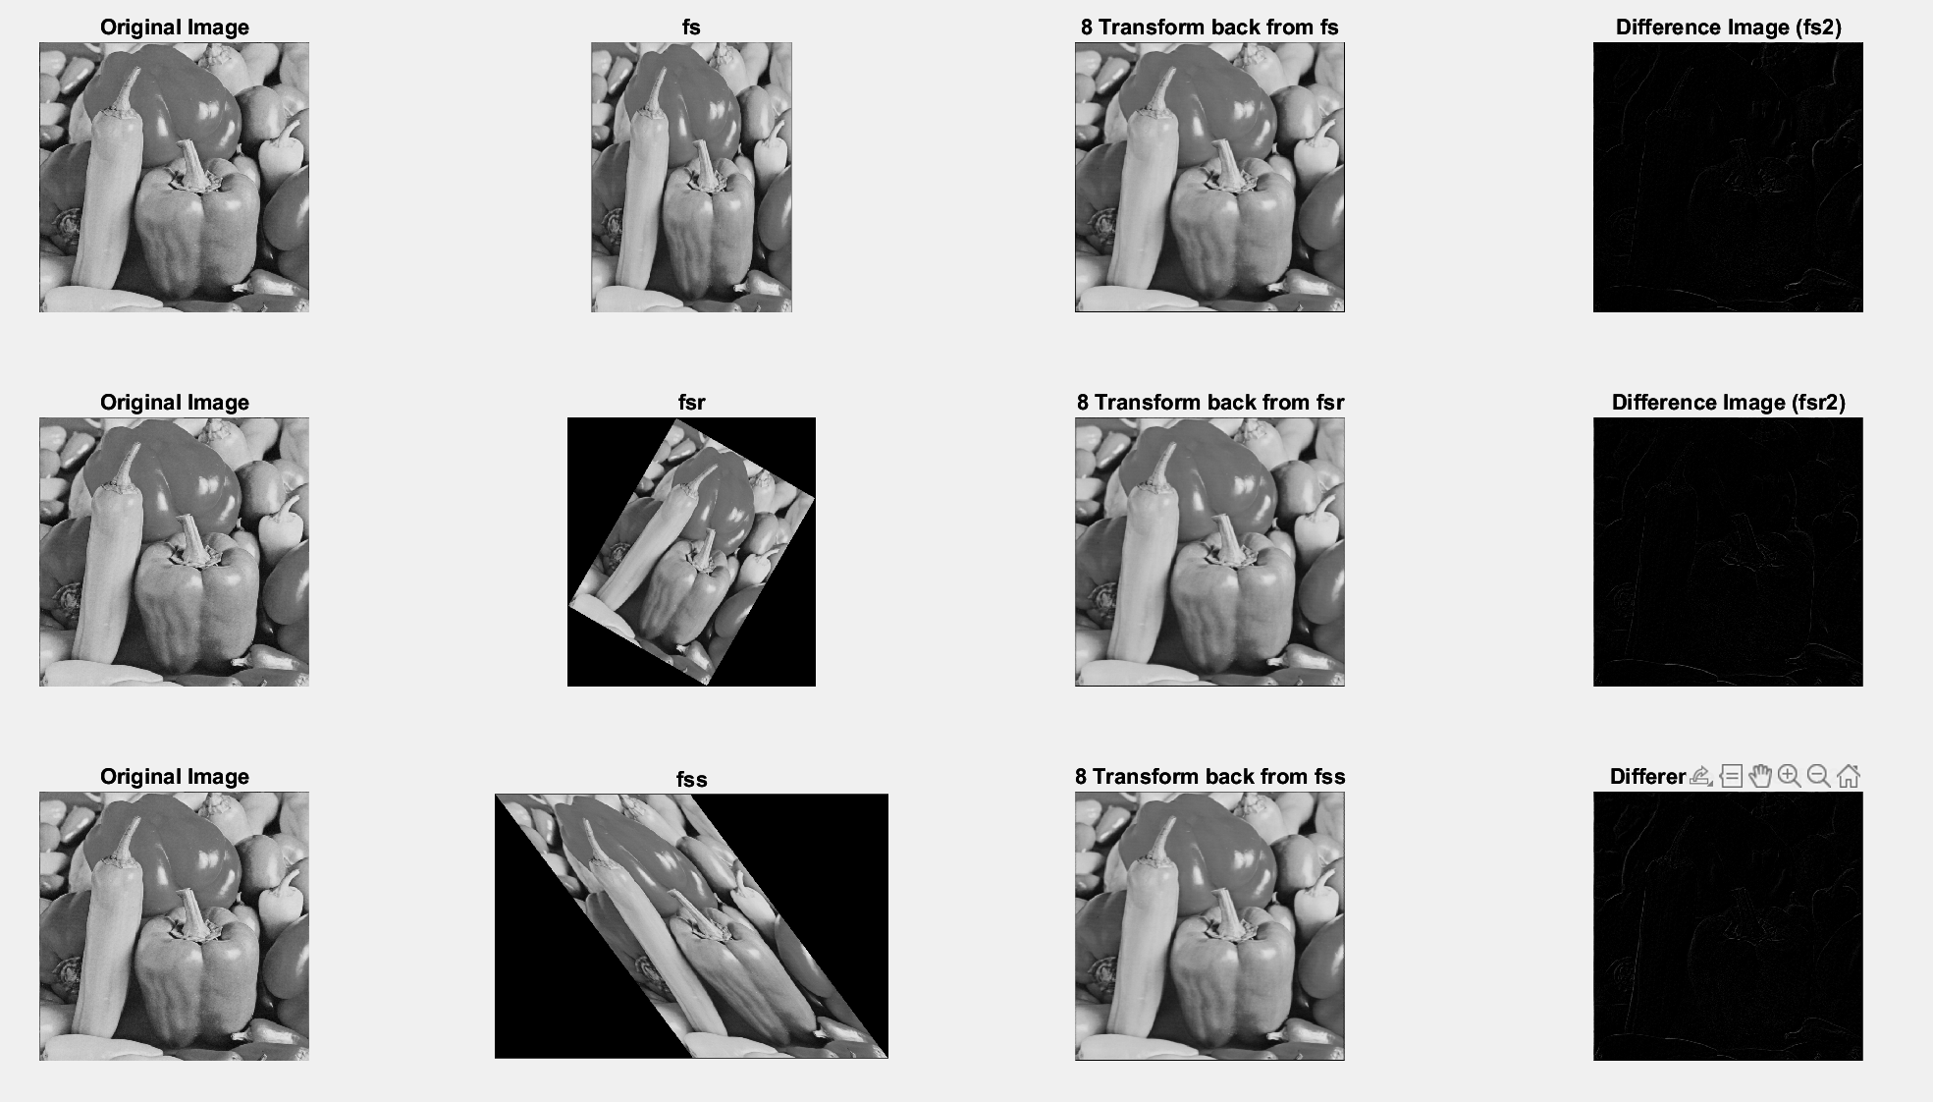

Theoretically, an image registered using 8 pairs should be more precise than one using 4 pairs, but the results don’t correspond to this theory. In my experiment, the difference image of the 8-pair registration appears to have **more noticeable edges** than the one with 4 pairs, which **doesn’t look better**. I believe this is because having more points can make the transformation more sensitive to errors in manually selecting control points. Therefore, the choice between using 8 pairs or 4 pairs should depend on the complexity of your transformation.